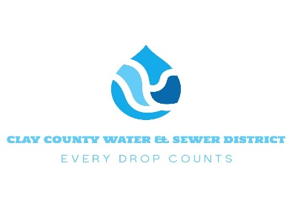
Non-Residential Application for Service
This Application Will Be Used To Determine Capacity Amount For Those Properties Requiring Additional Water and Sewer And To Determine Applicable System Development Fees.

Project Name: ______________________________________________________
Project Address: ____________________________________________________
Contact Name: _____________________________________________________
Contact Phone #: _________________ Contact Email: ____________________
Project Type: (i.e. Restaurant, Retail, Warehouse, etc.) _________________________________________

Project Total SQ. Ft.: __________________ Project Projected Seating: ______
Does the Project Have an Existing Account?: Yes ( ) No ( ) Acct. # _________
Service Requested: Both Water & Sewer ( ) Water Only ( ) Sewer Only ( )
Customer Signature: ________________________________________________
BY SIGNING, YOU ARE AGREEING TO OUR CUSTOMER POLICY AND TO THE TERMS IN THE DISTRICTS ALLOCATION ORDINANCE WHICH IS AVAILABLE ON OUR WEBSITE OR ON REQUEST

Office Use Only
Account #: ___________ Tap(s): Water ( ) Sewer ( ) Amount: ___________
System Development Fee Amount: _______________Paid By: ______________
Check ( ) # ________ Credit Card ( ) Cash ( ) Receipt #: ________________
Meter #: ______________ Meter Reading: ____________

