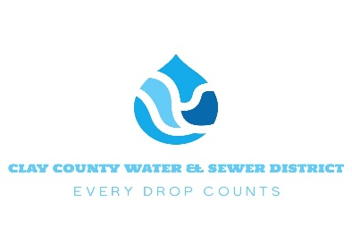
Application for Service

Name : ___________________________ Date: __________________
*Driver’s License #: ___________________ Sate of Issue: _________________
*Required for at the end of service, your final refund of security deposit check goes uncashed past 90 days, it will get sent to applicable state Unclaimed Money Department.
Home Phone #: ____________________ Cell Phone #: ___________________
Receive Text Alerts: Yes__ No__
By checking “Yes”, I expressly consent to Clay County Water and Sewer contacting me at the cell phone number provided for account notifications, service-related alerts, and other important communications, including those sent by text message or automated systems.
Email Address: ______________________ Move-In Date: _________________
Service Address: ____________________________________________________
Mailing Address (If Different From Service Address): _____________________________

Own ( ) Rent ( ) – Property Owner Name: _____________________________
Security Deposit Require: $100 for Property Owners / $200 for Renters
Service Requested: Both Water & Sewer ( ) Water Only ( ) Sewer Only ( )
Customer Signature: ________________________________________________
By Signing, You are agreeing to the terms in our customer policy available on our website or on request
Office Use Only
Account #: ____________________
Date of Deposit: ______________Amount: _________ Paid By: _____________
Check ( ) #: ________ Credit Card ( ) Cash ( ) Receipt #: _______________
Meter #: _______________ Meter Reading: __________________

